**Master Functional Document**

|  |  |
| --- | --- |
| **Application** | NGERP - Centra |
| **Service Bundle** | Master Management |
| **Service Request** | Warehouse & Locator |

**Description :**

This master is used to mange product like warehouse, locator and lot . Products can be maintained and monitored using this warehouse and locator master.

**Workflow Process :**

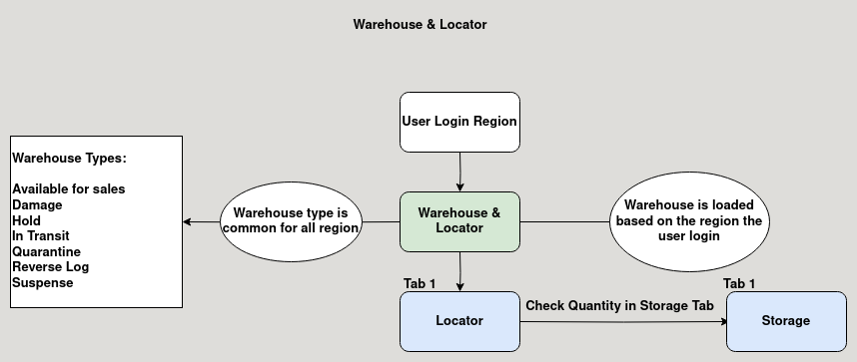

**Business Rules :**

* This Master is editable in regions only.
* User should login to their respective region to add warehouse or locator to that region.
* The warehouse type is common for all the region.
  + **Available for Sales:**

This type is Used for product Sales.

* + **Damage:**

This type is Used for product destruction.

* + **Hold:**

This type is Used for product Purchase.

* + **In Transist:**

This type is Used for sending and receiving branch transfer.

* + **Quarantine:**

This type is Used for near expiry product.

* + **Reverse Log:**

This type is Used when returning products both customer and vendor return.

* + **Suspense:**

This type is Used for stock adjustment.

* Warehouse for each region can be used identified with prefix Example: HCM, HNI etc ..
* Locator can be added to warehouse, each warehouse can have multiple locators.
* User can track the stock in micro level by warehouse, locator, lot.